TEST PLAN — E-COMMERCE STORE
COMP.SE.200-2026-2027-1 Software Testing | Part 1 — Test Plan
Group 31 | Pham Thanh | Georgios Malezoglou
Student numbers: [Insert both student numbers before submission]
Version: 1.0 | Date: 7 November 2026

Definitions and abbreviations
Term | Meaning
SUT | System under test: the selected utility-library source files
E2E | End-to-end; a complete user workflow across system components
CI | Continuous integration; automated verification on code changes
REST/API | Representational State Transfer / application programming interface
Coverage | Proportion of instrumented statements or branches exercised by tests
Stub | Controlled substitute for a dependency during a test
Unit test | A test of one small unit of code in isolation
Quality gate | A condition that must be satisfied before testing or a change is accepted

1. Introduction done

1.1 Purpose and deliverables
This plan explains what will be tested and why, how the tests will be designed, and how their results will be recorded and presented. It also explains how the results will help on deciding whether a helper functions library with no documentation can be reused in a food product e-commerce shop. It includes three E2E scenarios, 10 selected library functions in a priority order, a reproducible test approach, reporting and defect procedures, quality gates, detailed unit-test designs, and additional system-level testing recommendations. This is what Part 1 or this project will deliver, while part 2 includes the implementation of unit tests for the selected functions, GitHub Actions and Coveralls integration [1].

1.2 Application context and risk
Customers search and filter products based on name, category, price, ingredients and the product producer. Customers can navigate through the results (splitted in different pages), update their cart and use an external provider for payment. Producers can add products manually or through an existing bulk-import portal. Inputs like name, price and producer are mandatory while category and contents are not. The frontend has to validate prices, descriptions and order inputs. A REST backend takes care of third-party services and catalogue operations [1]. Products may hide by wrong filters, totals may be affected due to numeric conversion errors and poor validation may admit invalid product records. The library is available in a project that has be abandoned and documentation is missing, so a developer should not guess what each function based on the name alone.

2. Context of testing

2.1 Three representative E2E scenarios

S1 — Product search, filtering and pagination
Preconditions: A catalogue has multiple producers, optional missing attributes and more matches than fit on one page. Main flow: (1) customer opens catalogue; (2) enters a search term; (3) frontend validates and sends a REST request; (4) backend returns matches; (5) customer applies category, price, contents or producer filters; (6) the system combines criteria; (7) customer changes page; (8) the UI displays the correct subset while retaining filters. Alternatives: empty/whitespace query, zero results, absent optional fields, last/invalid page, or invalid price boundary. Expected outcome: only qualifying products appear; pagination is stable; empty results are explained. Candidate utilities: filter, every, toNumber, isEmpty, defaultTo, chunk, slice. Risk: incorrect predicates or page boundaries conceal or misrepresent stock. Activity diagram: Appendix A.

S2 — Cart, quantities and checkout
Preconditions: Products have valid prices; cart and checkout are accessible. Main flow: (1) customer selects products; (2) adds or removes an item; (3) changes quantity; (4) cart recalculates line totals and overall total after each action; (5) customer reviews the cart; (6) backend submits checkout data to the external provider; (7) the UI communicates the actual outcome. Alternatives: malformed, zero, negative or fractional quantities; empty cart; unavailable provider; duplicate submission. Expected outcome: correct cart state, appropriately rounded monetary presentation and no false payment-success message. Candidate utilities: add, reduce, toNumber, isEmpty (and toInteger/clamp as unselected alternatives). Risk: incorrect financial totals or duplicate purchases. Activity diagram: Appendix B. A general-purpose add is not assumed to guarantee decimal-currency correctness; application-level money handling needs separate tests.

S3 — Producer creation and bulk import
Preconditions: Producer can access the entry form or import portal; mandatory-field rules exist. Main flow: (1) producer chooses single entry or bulk import; (2) supplies product name, price, producer and optional details; (3) frontend/import service validates data; (4) invalid records are reported according to the import policy; (5) valid records are saved via REST; (6) producer confirms catalogue entries. Alternatives: missing required fields, optional nulls, malformed prices, mixed valid/invalid rows, duplicates and large batches. Expected outcome: no silently accepted invalid product, clear import result and consistent catalogue. Candidate utilities: toNumber, isEmpty, every, defaultTo, countBy; upperFirst is an unselected candidate for description formatting. Risk: corrupt catalogue data propagates into search and purchasing. Activity diagram: Appendix C.
These scenarios specify proposed application behaviour; the actual application and interfaces are not supplied. They guide the choice of library unit tests, not a claim that E2E testing can be executed in Part 2 [1].

2.2 Scope and risk-based selection
Only ten top-level src files will receive unit tests. The hidden .internal directory is assumed correct and excluded from both testing and coverage, as instructed [1]. The application frontend, REST backend, integration with the payment provider and executable E2E flows are outside the available implementation scope. Their recommended future tests appear in §4.3.
The group selected the following ten files using three 1–3 factors: scenario coverage (number of S1–S3 workflows supported), impact of failure (business harm) and estimated defect likelihood (complexity and edge cases). Total = coverage + impact + likelihood. This is a planning judgement, not an empirical defect probability. Ties prioritise higher impact, then higher coverage, then the group's chosen implementation relevance. Scores and the unselected candidates are recorded in Appendix D.

Selected file | Scenarios | Primary test focus
toNumber.js | S1, S2, S3 | Numeric coercion, invalid values and prices
filter.js | S1 | Predicate correctness, empty and mixed arrays
chunk.js | S1 | Page sizes, remainder and boundary inputs
isEmpty.js | S1, S2, S3 | Empty strings, arrays, objects and null-like data
add.js | S2 | Arithmetic, coercion and precision limitations
countBy.js | S3 | Group counts and duplicate detection support
reduce.js | S2 | Accumulation, initial value and empty collections
every.js | S1, S3 | All-condition predicates and empty collections
defaultTo.js | S1, S3 | Missing optional values and valid falsy values
slice.js | S1 | Start/end bounds and result subsets

clamp.js, toInteger.js, toString.js and upperFirst.js were considered but excluded under the ten-file limit; map.js and toFinite.js are additional plausible alternatives but are not part of the group's final selection. The prioritisation is a selection rationale; before Part 2, the team must confirm the functions' actual exported contracts and module compatibility against the repository. A library helper alone does not implement search, checkout or producer validation.

2.3 Assumptions and limitations
The library's .internal helpers are trusted only because the assignment explicitly permits that assumption; other src functions are not. Expected results should follow confirmed function semantics, not idealised application rules. Where an exported helper deliberately coerces inputs or returns IEEE-754 floating-point values, tests should document that behaviour and separately identify application-level risks. No application code, backend contract, payment sandbox or example product data will be supplied [1]. The team will report defects, not modify the library. Student responsibilities and scheduling are outside the required scope of this assignment [1].

3. Tools, reporting and quality controls

3.1 Environment and toolchain
Tool | Role | Reason for choosing
Node.js / npm | Envoronment to run code | Jest is a Node tool
Git / GitHub | Storage for tests, GitHub Issues to record possible deffects | Χρειάζεται ήδη για την παράδοση και για το CI.
Jest | Unit tests execution | Previous experience using it. Also, runner, assertions and coverage are all in one package.
Jest coverage | local sattement/branch data and LCOV output | Integrated into Jest, so no need for additional libraries.
GitHub Actions | Automated test execution for every push (Part 2) | Integrated into GitHub witn no external server.
Coveralls | Publish and | Παίρνει το LCOV του Jest και δείχνει το coverage ανά αρχείο.
The proposed Part 2 stack is Node.js/npm, Git/GitHub, Jest for test execution/assertions, Jest's coverage reporting for local statement/branch data and LCOV output, GitHub Actions for CI and Coveralls for published coverage. This is a concrete planned configuration rather than a claim of installation or successful execution. The existing repository's package.json, module format and scripts must be inspected before finalising Jest's ESM/CommonJS configuration; if incompatible, document the adjustment rather than silently changing the source. c8 is a viable alternative coverage tool but should not be layered over Jest coverage without a reason. Chai/Mocha, testdouble and third-party reporters are not required for the chosen approach. GitHub Actions and Coveralls are configured in Part 2, not Part 1 [1,3–6].
Reproducible setup outline: clone the supplied repository; record the tested commit and Node/npm versions; inspect package.json, source imports and existing tests; install locked dependencies where a lockfile exists (npm ci, otherwise npm install); add/configure Jest in the test project; create a minimal smoke test for one selected export; run Jest locally; enable collectCoverageFrom for only the ten selected files and exclude **/.internal/**; emit LCOV for Coveralls; in Part 2, add a GitHub Actions workflow to install, run tests and upload the LCOV report. Keep the source code unmodified and record commands/configuration in the repository README. Appendix E contains a configuration sketch, not a verified working command sequence.

3.2 Execution and result reporting
For each test run record date/time, branch and commit SHA, Node version, command, total/planned/executed/passed/failed/skipped/blocked tests, failing case IDs, expected versus actual output, coverage per selected file, and issue links. A failure is triaged first: verify the test oracle and environment before labelling a library defect. During testing, maintain a concise progress log; after testing, publish a report with results by function, unresolved issues, scenario implications and limitations. Archive test code, machine-readable test results, coverage/LCOV artefacts and GitHub Issues. Never present a blocked or unexecuted test as passed.

3.3 Defect tracking
Use GitHub Issues with labels for severity, priority, function and status. Workflow: New → Confirmed → Investigating → Documented/Resolved → Retest (if applicable) → Closed; a non-defect can be Rejected with an explanation. “Resolved” does not imply the team repaired library source code. Severity is technical/business impact (critical: materially unsafe totals or unusable core operation; high: important incorrect outputs; medium: bounded edge-case failure; low: minor unusual-input discrepancy). Priority is urgency (P1 immediate report, P2 prompt, P3 routine, P4 low). Severity and priority are recorded separately.
Issue template: title and ID; affected file/export; test-case ID; commit/environment; exact inputs and preconditions; steps; expected result with source of oracle; actual result; logs/screenshots if relevant; severity/priority; assignee/status; scenario consequence; and resolution/retest notes. Duplicate reports are linked rather than counted twice.

3.4 Metrics, entry/exit criteria and quality gates
Entry: ten files fixed; expected contracts inspected; runnable test environment and coverage configuration; cases have explicit inputs and oracles. Case pass: observed output equals the expected contract, including thrown exceptions where specified. Blocked: unmet prerequisite prevents execution; record separately. Exit: all planned cases executed or justified as blocked; failures triaged and recorded; coverage collected for the selected files only; uncovered paths and unresolved risks explained; final report produced. A stage is not declared clean if material failures remain, even when coverage is high.
Metric | Calculation / target
Execution rate | Executed / planned × 100; target 100% or documented exceptions
Pass rate | Passed / executed × 100; report observed rate, do not invent a target outcome
Confirmed defects | Count by function, severity and scenario consequence
Statement coverage | Covered statements / measurable statements; aim ≥80%
Branch coverage | Covered branches / measurable branches; aim ≥80% where available

These 80% thresholds are group targets, not assignment-mandated guarantees. Design normal, invalid, equivalence-class, boundary and negative tests; inspect uncovered branches; add meaningful tests or explain infeasible paths. Coverage measures execution, not correctness. For the ten-file scope, calculate coverage using the selected-file denominator, not the whole library.

4. Tests and AI in testing

4.1 Unit-test design principles
Unit tests call each selected export in isolation using deterministic input data and an explicit expected result. Use equivalence partitioning (valid/invalid types), boundary-value analysis (empty, singleton, near page limits), decision/branch coverage, negative tests and regression cases. Tests must be independent, repeatable and named by behaviour. A confirmed contract—not a desired e-commerce feature—is the oracle. Avoid testing internal implementation details or duplicating .internal tests. Use stubs only for external or nondeterministic dependencies; pure collection helpers should not need them. Where actual source semantics differ from a proposed oracle, review the contract and update the case before calling the mismatch a defect. The detailed designs below are planned test cases, not executed results.

4.2 Detailed test designs for two selected functions

Function A: `chunk.js` — pagination support (S1)
Assumed interface for test design: chunk(array, size) partitions an array into consecutive arrays of at most size elements, preserving order; the final chunk may be shorter. The precise default/invalid-size behaviour must be checked in the repository before implementation. No stubs are expected. Each case below states a concrete input and oracle for the normal positive-size contract.
ID | Input | Expected output | Purpose
CH-01 | [1,2,3,4,5], size 2 | [[1,2],[3,4],[5]] | Non-divisible page count
CH-02 | [1,2,3,4], size 2 | [[1,2],[3,4]] | Exact division
CH-03 | [], size 3 | [] | Empty catalogue
CH-04 | [7], size 3 | [[7]] | Fewer items than page size
CH-05 | [1,2,3], size 1 | [[1],[2],[3]] | Smallest positive size
CH-06 | [1,2,3], size 5 | [[1,2,3]] | Oversized page
CH-07 | ['a','b','c'], size 2 | [['a','b'],['c']] | Preserve values/order
CH-08 | [0,null,false], size 2 | [[0,null],[false]] | Preserve falsy values
CH-09 | [1,2,3], size 0 | Confirm source contract before asserting | Invalid/boundary size
CH-10 | [1,2,3], size -1 | Confirm source contract before asserting | Negative size handling

For CH-09/10, record the observed contract (empty result, coercion, error or other documented behaviour) before assigning an expected value; do not invent an application-level validation rule for the helper. Scenario link: CH-01/02/04/05/06 address first/last-page behaviour; S1 additionally needs integration tests for preserving filters when navigating pages.

Function B: `toNumber.js` — numeric conversion (S1, S2, S3)
Assumed interface for test design: toNumber(value) converts values according to the library's documented JavaScript number-coercion semantics; it does not itself validate a monetary amount or guarantee two-decimal currency precision. Compare NaN with Number.isNaN, not equality. No stubs are expected. Validate the exact source behaviour for whitespace, nondecimal syntax and objects before implementation.
ID | Input | Expected result | Purpose
TN-01 | '12.50' | 12.5 | Decimal price string
TN-02 | 0 | 0 | Zero remains zero
TN-03 | '-3' | -3 | Negative numeric conversion (not acceptance)
TN-04 | ' 42 ' | 42 | Surrounding whitespace
TN-05 | 'abc' | NaN | Malformed numeric text
TN-06 | '' | 0 | Empty-string conversion; app must separately reject blank price
TN-07 | null | 0 | Null conversion; app must separately reject missing price
TN-08 | true | 1 | Boolean coercion; not valid producer input
TN-09 | '0x10' | 16 | Nondecimal numeric notation
TN-10 | '1.234' | 1.234 | More than two decimal places remain unrounded
TN-11 | 'Infinity' | Infinity | Non-finite values need separate validation
TN-12 | ['7'] | Confirm source contract before asserting | Array coercion / unexpected input type

Scenario link: TN-01/04 support price-filter and product-entry parsing; TN-05/06/07/08/10/11 demonstrate why frontend/backend validation is needed after conversion. For S2, calculate a sample cart total separately (e.g. 2 × €3.25 + 1 × €1.40 = €7.90) and test formatting/rounding at the application layer, not as a promised toNumber feature.

Coverage of the other eight selected files
For filter, test matching/nonmatching predicates, empty collections and multiple records. For isEmpty, compare empty/nonempty arrays, strings and objects. For add, test positive/negative/zero operands and floating-point behaviour without assuming currency rounding. For countBy, test repeated categories, unique values and empty arrays. For reduce, test an initial accumulator, empty input and noncommutative reducer order. For every, test all/one/none matching and the empty-array case. For defaultTo, distinguish null/undefined/NaN from meaningful falsy values such as 0 and false as dictated by the source. For slice, test negative indexes, out-of-range indexes, empty results and order preservation. Link test case IDs to source files and S1–S3 in the Part 2 report.

4.3 Additional testing for the complete e-commerce system
Functional E2E (highest business priority): execute S1 with combined filters, no results, optional missing fields and pagination; S2 with quantity changes, empty cart, price totals, failed checkout and duplicate-submission protection; S3 with valid/invalid records, partial import, duplicates and catalogue verification. Use realistic fixtures and verify backend persistence, not only frontend messages.
API/integration: test REST validation and response codes, schema/contract compatibility, catalogue/cart persistence, producer access permissions, checkout request mapping, provider timeout/retry and duplicate-payment prevention. Stub the external payment service for deterministic failure tests, then run a small sandbox contract test where permitted. Confirm whether bulk import is atomic or partial before asserting its behaviour.
Security and data integrity: test input sanitisation/XSS, authorization for producer operations, CSRF where session-based, injection resistance, rate limiting and protection of payment-related data; avoid real customer or card data. Verify required fields and two-decimal monetary policy server-side, since frontend checks can be bypassed.
Nonfunctional and usability: performance of large catalogues, filter combinations and bulk imports; pagination stability; accessibility of search/cart/errors; cross-browser/mobile layout; resilience to network interruption; and recovery from service failure. Prioritise price integrity, authorization, checkout reliability and product-data correctness before cosmetic concerns. These tests are recommendations, not executable Part 2 deliverables because the application is unavailable [1].

4.4 AI use, opportunities and safeguards
Actual Phase 1 use: ChatGPT was utilized help structure and edit this report, propose scenario-to-function mappings, refine the prioritisation explanation, draft unit-test cases and outline additional testing risks. The team remained responsible for verifying all library contracts, testing tools, citations, diagrams, and the final content included in the report against the assignment requirements and source materials. No AI-generated test cases were considered "executed," and no test coverage or defect results were fabricated. The final submission must be reviewed and revised by both team members to account for any additional tools they may have employed.
Potential Phase 2 use: AI can suggest equivalence classes, edge cases and initial Jest test skeletons for the ten selected functions; assist in interpreting failing test output and identifying untested branches; and draft readable issue reports. This is especially useful with missing library documentation and conversion/empty-input edge cases. Risks include hallucinated function contracts, incorrectly asserted expected values, superficial tests that only repeat implementation behaviour, overlooked security cases and leakage of proprietary code/data. Mitigation: inspect source before adopting any suggestion, manually validate numeric and boundary oracles, keep reviewable tests in GitHub PRs, use synthetic data, and report AI assistance transparently. AI is an assistant, not an independent test oracle or substitute for human verification [1].

5. References
[1] Tampere University, COMP.SE.200 Software Testing: Practical 1 — Part 1 Test Plan and submission instructions, 2026 (course-provided assignment text).
[2] Utility library repository: https://github.com/otula/COMP.SE.200-2024-2025-1
[3] Jest documentation: https://jestjs.io/docs/getting-started
[4] GitHub Actions documentation: https://docs.github.com/en/actions
[5] Coveralls documentation: https://docs.coveralls.io/
[6] Node.js documentation: https://nodejs.org/en/learn

Appendix (excluded from ten-page main-content limit)

Appendix A — S1 activity diagram
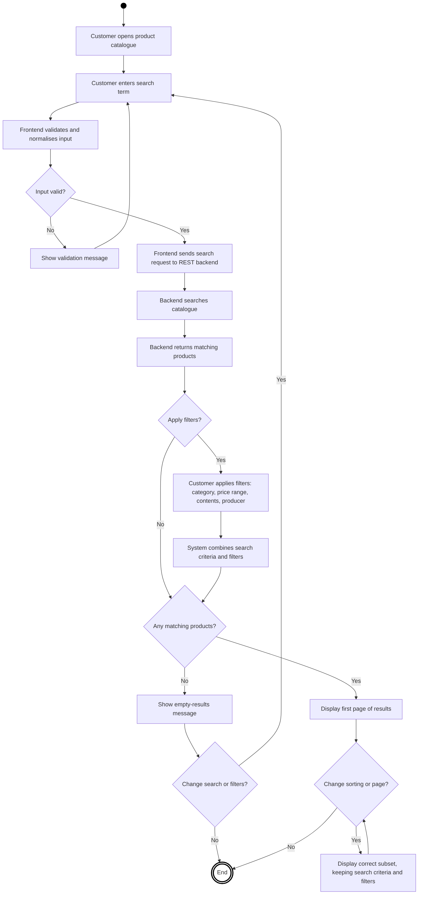

Appendix B — S2 activity diagram
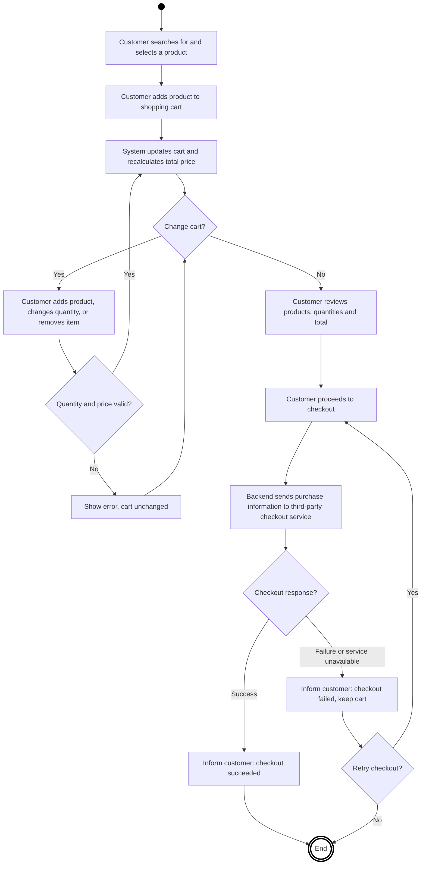

Appendix C — S3 activity diagram
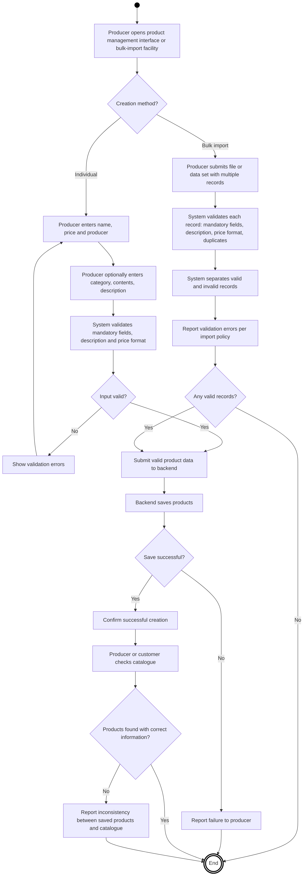

Appendix D — Candidate prioritisation register
File | Scenarios | Coverage | Impact | Likelihood | Total | Decision
toNumber.js | 1,2,3 | 3 | 3 | 2 | 8 | Selected
filter.js | 1 | 1 | 3 | 3 | 7 | Selected
chunk.js | 1 | 1 | 3 | 3 | 7 | Selected
isEmpty.js | 1,2,3 | 3 | 2 | 2 | 7 | Selected
add.js | 2 | 1 | 3 | 2 | 6 | Selected
countBy.js | 3 | 1 | 2 | 3 | 6 | Selected
reduce.js | 2 | 1 | 3 | 1 | 5 | Selected
every.js | 1,3 | 2 | 2 | 1 | 5 | Selected
defaultTo.js | 1,3 | 2 | 2 | 1 | 5 | Selected
slice.js | 1 | 1 | 2 | 2 | 5 | Selected
clamp.js | 2 | 1 | 1 | 3 | 5 | Not selected
toInteger.js | 2 | 1 | 2 | 1 | 4 | Not selected
toString.js | 1 | 1 | 1 | 2 | 4 | Not selected
upperFirst.js | 3 | 1 | 1 | 1 | 3 | Not selected

The score-5 tie is not uniquely resolved by impact alone: slice and clamp both score 5, but slice has greater direct relevance to the agreed pagination scenario. This documented judgement preserves the group's ten-file decision. Scores are planning estimates, not source-verified measurements.

Appendix E — Planned Jest configuration sketch
// Illustrative only: confirm module format and source paths before Part 2.
module.exports = {
testEnvironment: 'node',
collectCoverage: true,
coverageReporters: ['text', 'lcov'],
collectCoverageFrom: [
'src/{toNumber,filter,chunk,isEmpty,add,countBy,reduce,every,defaultTo,slice}.js',
'!src/.internal/**'
]
};

Final submission check: insert both student numbers; confirm exported function contracts and adjust provisional oracles; review AI declaration; check diagrams and page count; export the final PDF and name it 31_STUDENT1_STUDENT2_2026_part1.pdf with the actual student numbers; submit to Moodle before the stated deadline [1].

